PLYMOUTH UNITED BASKETBALL CLUB APPAREL ORDERING FORM
Please help us raise money for our program to lower costs & expenses
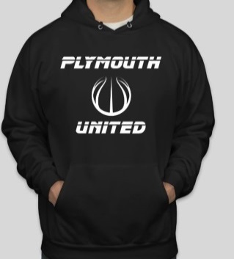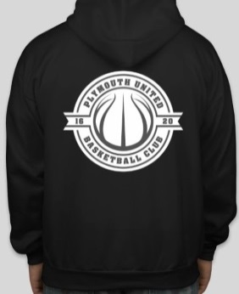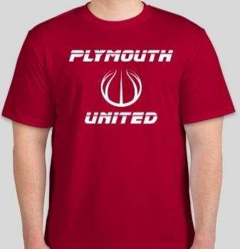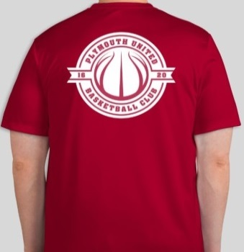
To View All The Different Colors of Sweatshirts & T-Shirts go to www.plymouthunited.com/apparel/
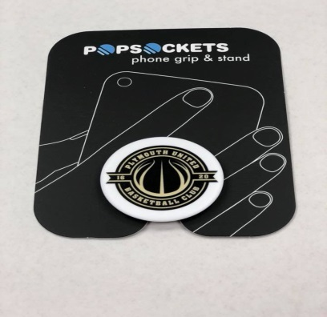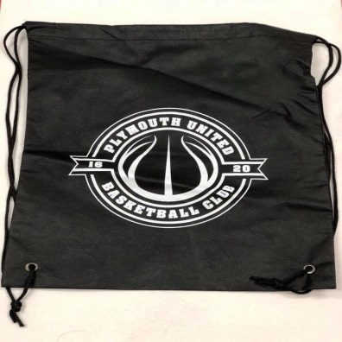
United Sweatshirts $40.00 United T-Shirts $20.00
United Cinch Bag $10.00 United Pop Socket $15.00
Sweatshirt Quantity ____ Size _____ Circle Color: Black, Blue, Red, Light Blue, Pink, Green, Orange, Purple, Navy
Sweatshirt Quantity ____ Size _____ Circle Color: Black, Blue, Red, Light Blue, Pink, Green, Orange, Purple, Navy
Sweatshirt Quantity ____ Size _____ Circle Color: Black, Blue, Red, Light Blue, Pink, Green, Orange, Purple, Navy
T-Shirt Quantity ____ Size _____ Circle Color: Black, Blue, Red, Light Blue, Pink, Orange, Navy, Purple
T-Shirt Quantity ____ Size _____ Circle Color: Black, Blue, Red, Light Blue, Pink, Orange, Navy, Purple
T-Shirt Quantity ____ Size _____ Circle Color: Black, Blue, Red, Light Blue, Pink, Orange, Navy, Purple
Popsocket Quantity _____
Cinch Bag Quantity _____
Name: ___________________________ Total Amount Paid: $________

